Multiple Random Variables

Quick Reaction (QRC) Radio Locator System

Team: MCCCXXXVII

Team Leader: Colin Fischer

Team Members: Mike Doran, Carlos Lazo, Carolyn Andrews

Course: TDC1 – Multiple Random Variables

Instructor: Dr. Karl Brommer

Group Hours: 25

Date Submitted: 10/24/2008

Executive Summary

Problem

Over the past month, our team, Team MCCCXXXVII, developed a software patch for Blackhawk helicopter surveillance receivers. This patch allowed them to detect foreign paramilitary groups who were using key-click High Frequency (HF) radios to communicate. Now that we can successfully identify the radios, our customer, Sideband ANTenna Association (SANTA), has requested that we quickly develop a quick reaction (QRC) radio locator system. Our main focus is to predict the performance of the QRC location processor through probability analysis. Our customer requires that we locate all enemy key-click radios by early December.

Method of Analysis

In this project, our group, Team MCCCXXXVII, will be leveraging knowledge gained from previous projects. In the past, we developed software for identifying HF sideband radios. In this new effort, we will create a software patch that processes data received from two helicopters that were sent out to listen for enemy radio key clicks. Key clicks are the signature signals of the HF sideband radios. Each helicopter will record both time and Doppler-shifted replica signals when scanning for the transmitter. The signals will be separated by a time shift, which will be dependant on helicopter locations with respect to the enemy radio.

Our probability model must account for a Time Difference of Arrival (TDOA) error since we will not be able to identify the exact location of the helicopters at any given point in time. We will also have a Frequency Difference of Arrival (FDOA) error due to changing helicopter velocities. These errors are composed of both mechanical and geometric constraints, with their respective probability density functions modeled as independent Gaussian distributions. In calculating our overall variance for time shift and frequency as well as the joint probability density function of the errors, we will be able to predict the location of the radio with a high degree of confidence. Our initial problem models our FDOA and TDOA density functions at 90 degree angles. In order to represent a more realistic scenario, we will analyze helicopter readings when the densities intersect at 45 degree angles and see how the joint probability density function is affected. The MATLAB R2008a software package is used for all graphical and mathematical computations.

Results / Recommendations

Our software patch can successfully identify the location a foreign radio with an accuracy of 95%. We recommend that our customer, SANTA, implement our software patch as soon as possible to meet their early December deadline of locating all the naughty key-click radio users. We also ask the customer to consider the improved system location accuracy from a developed system Concept of Operations (CONOPS) for future business.

Table of Contents
Executive Summary 2
Problem 2
Method of Analysis 2
Results / Recommendations 2
Problem Statement 5
Overview 5
System Description 5
Assumptions 7
System Analysis 8
Approach 8
Detailed Analysis 8
Cross Ambiguity Function (CAF) Processing 8
TDOA Error Analysis 9
FDOA Error Analysis 10
CAF Error Analysis 10
Confidence Interval 11
Helicopter Dynamics 12
Results 13
Results 13
Recommendations 15
System Concept of Operations 15
References 17
Appendix 18
Appendix A – MATLAB Code 18
CAF_Processing.m 18
CAF_Error_Analysis.m 19

List of Figures

Figure 1: Helicopter Area Analysis 5
Figure 2: Geometric Change from Angular Adjustment to Errors 6
Figure 3: Cross Ambiguity Function, Time Shift vs. Frequency 9
Figure 4 - CAF Error Analysis 11
Figure 5 - 95% Confidence Interval 11
Figure 6 - 45 Degree Intersection between TDOA/FDOA Errors 12
Figure 7 - 45 Degree Intersection between TDOA/FDOA Errors (Top View) 12

List of Tables
Table 1: Components of Error for TDOA Error Analysis 9
Table 2: Components of Error for FDOA Error Analysis 10
Table 3: Summary of Results 13

Nomenclature
Symbol | Definition | Units
τ | Time Difference | Seconds (s)
σ | Standard Deviation | ---
σ² | Variance | ---
f | Frequency Difference | Hertz (Hz)
A(τ,f) | Cross Ambiguity Function | ---
t | Time | s
λ | Wavelength | Meter (m)
α | Sweep Rate | Radian/s

Problem Statement

Overview

Our team has developed a software patch for use on Blackhawk helicopters that can identify when a HF key-click radio is being used by foreign paramilitaries. Upon further research, it was determined that these insurgents are merely children who happen to be subject matter experts at signal propagation and jamming. Our customer, Sideband ANTenna Association (SANTA), would like to identify the exact location of these radios so they can differentiate between naughty and nice children. Use of a key-click radio is associated with naughty children. Those who use the key-click radio will get coal in their stockings come late December.

SANTA is currently using Blackhawk helicopters to monitor key-click radio activity. They would like to update the software to detect location of these radios as well. SANTA has acquired a radio from the foreign paramilitary that our team can use for testing. Our group will use Apache helicopters for this part of the mission due to their increased speed and maneuverability. We will develop a Time Difference of Arrival/Frequency Difference of Arrival (TDOA/FDOA) quick reaction (QRC) radio locator system to pinpoint the location of the transmitters. Our software patch will take recordings from the radios currently in service and post-process the data. We will analyze our software patch using probability analysis to predict the accuracy of our location processor within a 95% confidence interval.

System Description

Our system consists of two Apache helicopters circling a targeted area trying to locate enemy key-click radios. These helicopters are equipped with a detection system that utilizes a patch our team previously developed. Figure 1 shows the geometric model used to describe our system:

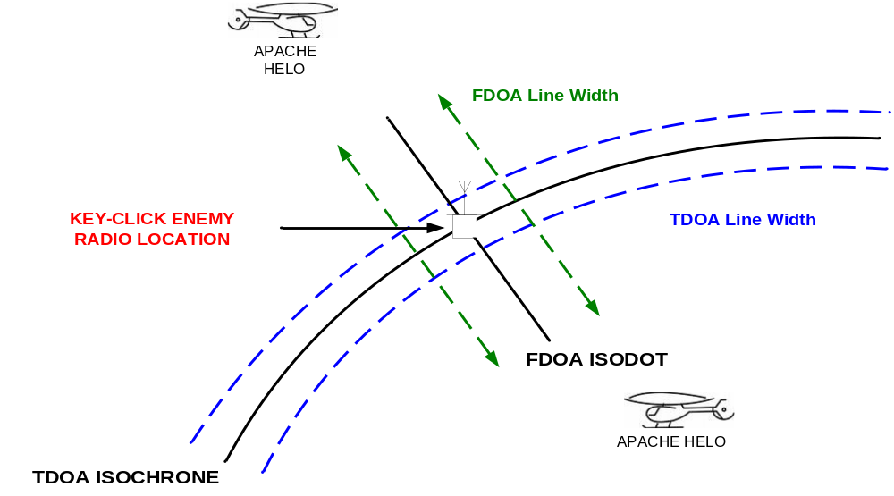
Figure 1: Helicopter Area Analysis
In calculating the Cross Ambiguity Function (CAF) for the signals recorded by both helicopters, we find maximum values for the differential time delay and differential Doppler frequency between both Apache helicopter platforms. The maximum time delay allows us to find the emitter somewhere on a hyperbolic line, with both foci being located at the two helicopters. This hyperbola is known as a TDOA isochrone. The maximum differential Doppler creates another line based on helicopter velocities. This line is known as an FDOA isodot. Given FDOA and TDOA line widths which are centered about the isochrone and isodot respectively as depicted by the dotted lines in Figure 1, we determine the area where we think our receiver is located.

Knowing this area based on the line widths, we use the independent Gaussian probability density functions (PDF) for the FDOA and TDOA errors to plot a joint error PDF. This analysis allows our group to calculate and display a 95% confidence interval on our emitter location accuracy.

Initially, the error analysis is done with the FDOA and TDOA intersecting at 90 degree angles. In a more realistic environment, the helicopters will be in different location and moving at changing velocities. The same analysis is performed when the errors intersect 45 degree angles. The overall geometry changes to a longer rectangle, where the area being analyzed represents that of a rhombus. This can be seen in Figure 2.

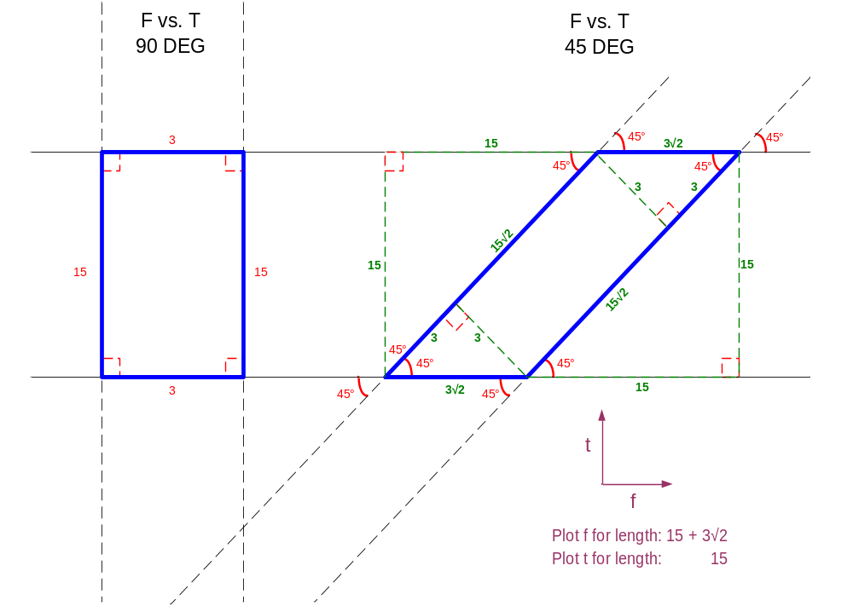
Figure 2: Geometric Change from Angular Adjustment to Errors

Assumptions
- FDOA and TDOA are assumed to be independent following Gaussian distributions.
  - This was determined from existing knowledge provided to our group
- The TDOA line widths surrounding the isochrone are assumed linear when doing area calculation in the target emitter region
  - This can be assumed since the TDOA has such a large radius and error region is very small in comparison and to aid in mathematical simplicity

System Analysis

Approach

The basic key click signal was calculated in a previous BAE SYSTEMS project. Our team is leveraging that project and searching for the signal using two Apache helicopters. These helicopters scan for the signal, resulting in two collected time and Doppler shifted replica signals, s₁ and s₂, embedded in noise, where s₂ has a time shift, τ.

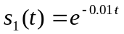 Equation 1
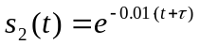 Equation 2

The Cross Ambiguity Function (CAF) is used to detect and locate the signal. There is error associated with receiving the signal due to helicopter position, known as the time difference of arrival (TDOA) for the signal. Another error exists that is attributed to helicopter velocity, which is known as the frequency difference of arrival (FDOA). Each error is assumed independent and follows a Gaussian distribution. By calculating overall variance for τ and frequency as well as the joint probability density function of the errors, it is possible to predict the emitter location with to a high confidence level.

Detailed Analysis

Cross Ambiguity Function (CAF) Processing

We begin our analysis by examining the Cross Ambiguity Function (CAF) attributed with signal frequency shift and time delay as seen in Equation 3:

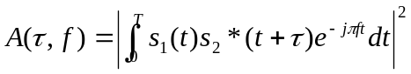 Equation 3

The CAF uses the signals received from each helicopter platform, s₁ and s₂, as described by Equations 1 and 2. By combining the two signals through a convolution operation and comparing the signals as the helicopters move, it is possible to locate the emitter. The CAF correlates our two waveforms as functions of time delay and frequency between specific ranges of values. The CAF is calculated numerically and plotted using MATLAB as seen in Figure 3.

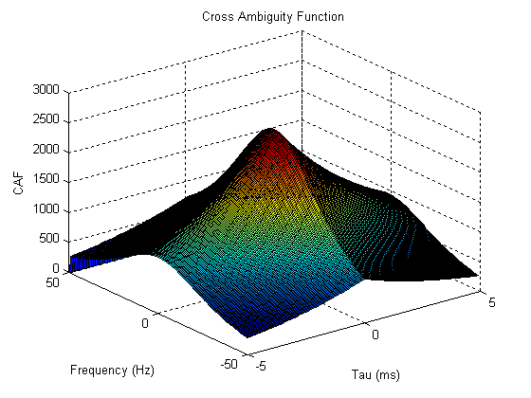
Part A Solution
Figure 4: Cross Ambiguity Function, Time Shift vs. Frequency

TDOA Error Analysis

There is error associated with the time delay measurement, τ, of the signals. This is a result of error in helicopter position as well in the pulse time delay estimation. These errors are independent Gaussian random variables and have the variances shown in Table 1.

Table 1: Components of Error for TDOA Error Analysis
Component of Error | Variance
Helicopter position error | 2σ²_{p}
Pulse time delay estimate | σ²_{TDOA}

The typical uncertainty in helicopter position along one dimension is labeled σ_{p}, and σ_{TDOA} is the typical uncertainty in pulse time of arrival measurement. The variance of the time delay measurement can be calculated by summing the variance of the components of error as seen in Equation 4:

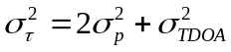 Equation 4

The probability density for τ, p(τ) is Gaussian and can be written in terms of the newly calculated error variance, as seen in Equation 5:

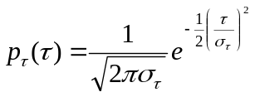 Equation 5
Part B Solution

FDOA Error Analysis

The FDOA error, originating from the differential Doppler based on the helicopter velocities, is calculated following a similar method as the TDOA. However, there are more components for error. Table 2 shows the components for this error.

Table 2: Components of Error for FDOA Error Analysis
Component of Error | Variance
Helicopter position error | α²σ²_{p}/λ²
Pulse differential Doppler estimate | σ²_{FDOA}
Helicopter velocity | 2σ²_{v}

The typical uncertainty in helicopter position along one dimension is known as σ_{v}. We call the angular sweep rate of the helicopter with respect to the emitter α. The typical uncertainty in pulse differential frequency measurement is known as σ_{FDOA}. In order to calculate the probability density, p(f), for the FDOA error, we first must calculate the frequency variance. Equation 6 shows that the frequency variance is a function of the variance for each component of error:

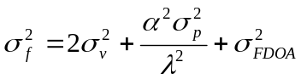 Equation 6

The p_{f}(f) is a Gaussian function that depends on the newly calculated variance of the frequency as shown in Equation 7:

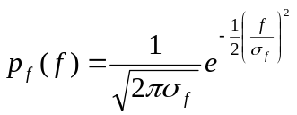 Equation 7
Part C Solution

CAF Error Analysis

A coworker who has been working this project in Internal Research and Development (IRAD) has supplied us values we can use to perform a numerical analysis. The standard deviation of the TDOA, σ_{TDOA}, is equal to the TDOA line width of 15 kilometers. Similarly, the standard deviation for the FDOA, σ_{FDOA,} is equal to the FDOA line width of 3 kilometers. We substitute these and the other given values into Equations 4 and 6 to calculate the new TDOA and FDOA variances. These newly calculated values are then plugged into Equations 5 and 7 to yield the probability density functions of the two errors.

As mentioned previously, the TDOA and FDOA errors are independent Gaussian random variables. This implies that the joint probability density functions of the errors are the multiplication of the individual density functions, as seen in Equation 8.

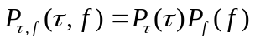 Equation 8

Using MATLAB, we plot the target location error joint probability for the case where the TDOA and FDOA lines intersect at right angles, as seen in Figure 4:
Part D Solution

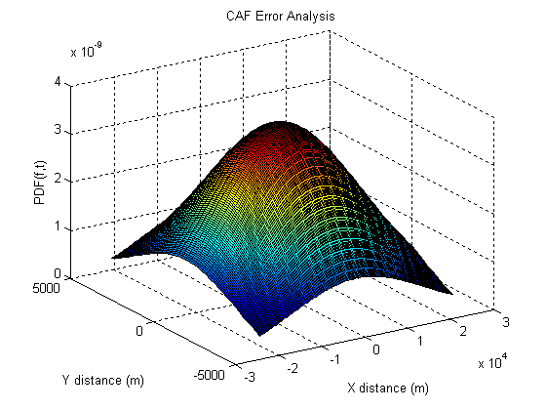
Figure 5 - CAF Error Analysis

Confidence Interval

Near-perfect accuracy is very expensive to obtain. Although BAE SYSTEMS strives for perfection, our customer has asked for a 95% confidence in our result. The 95% confidence interval is the area within two standard deviations of the mean of the CAF Error joint probability density function. The confidence range yields an elliptical result that can be seen in Figure 6.

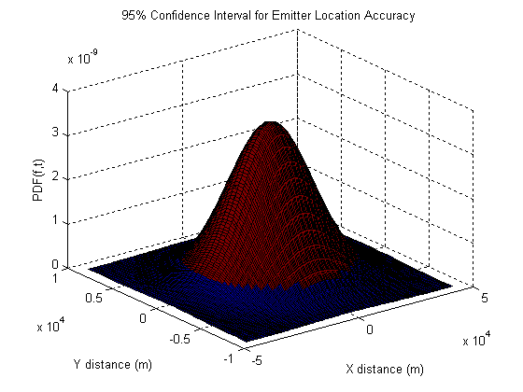
Part E Solution
Figure 6 - 95% Confidence Interval
Figure 5 is actually the same graph as Figure 4, but the ranges were increased to allow the confidence interval ellipse to be seen. The MATLAB plot shows that 95% of the joint probability density is contained below the red area of the graph. Our team is 95% confident that the emitter is located somewhere within this red area.

Helicopter Dynamics

Up to this point, the system required the TDOA and FDOA errors to be perpendicular. However, helicopters are constantly in motion and error lines will rarely be perpendicular to each other. In order to analyze a more realistic helicopter configuration, SANTA, our customer, asked that our system detect the key-click emitter when the TDOA and FDOA lines and intersect at 45 degree angles. We adjusted our MATLAB code, skewing the FDOA error by 45 degrees, resulting in the joint probability function plot shown in Figure 6:
Part F Solution

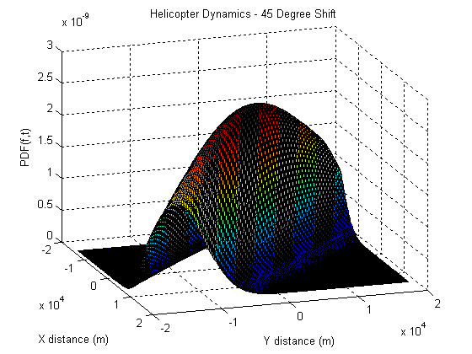

Figure 7 - 45 Degree Intersection between TDOA/FDOA Errors
A top level view of this graph shows that the emitter is most likely to be located in the center of this elongated ellipse whose major axis is now centered at 45 degrees between both axes. This can bee seen in Figure 7:

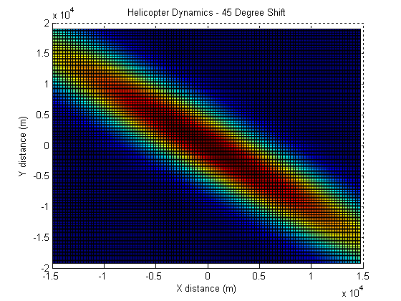

Figure 8 - 45 Degree Intersection between TDOA/FDOA Errors (Top View)

Our team proposes a system Concept of Operations (CONOPS) in our recommendations that will help improve the system location accuracy performance.

Results

Results

Table 3: Summary of Results

Part | Solution
A | This graph describes the Cross Ambiguity Function (CAF) in terms of time delay and differential Doppler of our recorded helicopter signals. This is used to detect and locate the emitter and to determine maximum f and T values.
B | 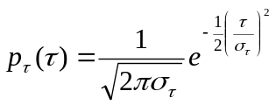  This is the probability density for the TDOA measurement error in terms of the error variances.
C | This is the probability density for the FDOA measurement errorin terms of the error variances.
D | This graph displays the target location error joint probability for the case where the TDOA and FDOA lines intersect at right angles.
E | This graph represents our 95% confidence value based on emitter location accuracy.
F | These graphs show what happens to the joint probability function when the lines of TDOA and FDOA intersect at45 degree angles.
G | Each repeated helicopter sample would improve our overall system location accuracy performance by a factor of 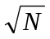. Refer to the Recommendations section for our system Concept of Operations (CONOPS).

Recommendations

Based on all information presented, our group, Team MCCCXXXVII, recommends that SANTA implement our software patch immediately. Once implemented, our patch will allow SANTA to locate the paramilitary key-click radios quickly and effectively in a short period of time. This will allow SANTA to meet the early December deadline of identifying the naughty children who continue transmitting over these radios.

System Concept of Operations

The system location accuracy performance could be improved by allowing repeated dwells on the same pulses as the helicopters sweep in a chosen pattern. The helicopter will send out multiple pings of the key click radio and then compare the new signal response to the previously received signal. Pin point accuracy could be obtained using this method if the sample size was large enough. For a calculation made using N samples, the overall error drops by a factor of . Pin point accuracy could also be obtained using a single helicopter if it were sampling at an extremely high rate. Since the helicopters are moving at all times, the TDOA and FDOA lines used to determine the radio location are rotating at different angles. By looking at several rotations of lines, we can bring the edges of our overall combined joint probability density function closer to the mean. Ideally, one giant hill would exist in our joint density function, indicating the location of the emitter with greater accuracy and precision.

We ask that SANTA consider our system CONOPS for future business.

References

Stein, Seymour. “Algorithms for Ambiguity Function Processing.” IEEE Transactions on
Acoustics, Speech, and Signal Processing VOL. ASSP-23, NO.3 (June 1981): 588-599

Appendix

Appendix A – MATLAB Code

CAF_Processing.m

%% TEAM MCCCXXXVII
% Week 07 - Multiple Random Variables

% Part A - Cross Ambiguity Function

% Array for t
t = (0:10000);

% Step size for Freq and Tau
df = .5;
dtau = 1;

% Make a big'ol matrix to put our CAF in!
A = zeros(200,100);

% For a bunch of Freqs and a bunch of Taus,
for f = -50:df:49
for tau = -50:dtau:49

% Calculate an S1 and an S2
s1 = [zeros(1,250) exp(-.01*t(1:750))];
s2 = [zeros(1,tau+250) exp(-.01*(t(1:750-tau)))];

% Multiply our S1 S2 and the Freq Shift, Integrate
A((f+50)/df+1,(tau+50)/dtau+1)=sum(s1.*s2.* exp(-j*2*pi*f*t(1:1000)/10000));
end
end

% Absolute Value and Square the guy!
A = abs(A);
A = A.^2;

% Let's draw a plot!
surf([-50:dtau:(50-dtau)]./10,[-50:df:(50-df)],A);
ylabel('Frequency (Hz)')
xlabel('Tau (ms)')
zlabel('CAF')
title('Cross Ambiguity Function')

CAF_Error_Analysis.m

%% TEAM MCCCXXXVII
% Week 07 - Multiple Random Variables

clear all;
close all;

std_tdoa = 15000; % TDOA Line Width
std_fdoa = 3000; % FDOA Line Width
std_p = 10*(10^-9); % Position Error
std_v = 0.01; % Velocity Error
alpha = 0.005; % Sweeping Rate
lambda = 30; % Wavelength

%% Part D: CAF Error Analysis

% Variance and standard deviation calculated for TDOA Error

var_T = 2*(std_p^2) + std_tdoa^2;
std_T = sqrt(var_T);

% Variance and standard deviation calculated for FDOA Error

var_F = 2*(std_v^2) + ((alpha^2 * std_p^2)/(lambda^2)) + std_fdoa^2;
std_F = sqrt(var_F);

mult = 3; % Multiplicity value to increase plotting range increased range

% Set sample steps for each of the ranges

df = 250;
dt = 250;

% Create vector to store data points based on sampling steps

M = zeros(3000/df*mult,15000/dt*mult);

count = 1; % Counter variable to aid in matrix data placement

t = -7500*mult:dt:7499*mult; % Create a vector to iterate over t values.

% Iterate over a range of FDOA values, ranging the 3000 kilometer distance

for f = -1500*mult:df:1500*mult

% Compute the individual pdfs based on different values
% and store into matrix M.

pdf_f = (1/sqrt(2*pi*var_F))*exp(-.5*((f/std_F)^2));
pdf_t = (1/sqrt(2*pi*var_T))*exp(-.5*((t./std_T).^2));

M(count,:) = pdf_f * pdf_t;

count = count + 1;

end

x = -7500*mult:dt:7499*mult;
y = -1500*mult:df:1500*mult;

% Create a plot for Part D.

figure
surf(x,y,M)
ylabel('Y distance (m)')
xlabel('X distance (m)')
zlabel('PDF(f,t)')
title('CAF Error Analysis')

%% Part E: Confidence Interval Analysis

% Variance and standard deviation calculated for TDOA Error

var_T = 2*(std_p^2) + std_tdoa^2;
std_T = sqrt(var_T);

% Variance and standard deviation calculated for FDOA Error

var_F = 2*(std_v^2) + ((alpha^2 * std_p^2)/(lambda^2)) + std_fdoa^2;
std_F = sqrt(var_F);

mult = 6; % Multiplicity value to increase plotting range increased range

% Set sample steps for each of the ranges

df = 500;
dt = 500;

% Create vector to store data points based on sampling steps

M = zeros(3000/df*mult,15000/dt*mult);

count = 1; % Counter variable to aid in matrix data placement

t = -7500*mult:dt:7499*mult; % Create a vector to iterate over t values.

% Iterate over a range of FDOA values, ranging the 3000 kilometer distance

for f = -1500*mult:df:1500*mult

% Compute the individual pdfs based on different values
% and store into matrix M.

pdf_f = (1/sqrt(2*pi*var_F))*exp(-.5*((f/std_F)^2));
pdf_t = (1/sqrt(2*pi*var_T))*exp(-.5*((t./std_T).^2));

M(count,:) = pdf_f * pdf_t;

count = count + 1;

end

x = -7500*mult:dt:7499*mult;
y = -1500*mult:df:1500*mult;

% Create a matrix to fit an ellipse inside.

C = zeros(size(M));

for m = 1:size(M,1)
for n = 1:size(M,2)

% Which squares are inside the ellipse? Lets mark them with 1's.
% Axis come from 2 std devs, which represents the 95% confidence
% interval. This is building a contour map which will color
% the resultant graph.

if ((m*df-size(M,1)*df/2)^2/(2*std_F)^2 + (n*dt-size(M,2)*dt/2)^2/(2*std_T)^2)<1
C(m,n) = 1;

end
end
end

% Now, use our ellipse to color the hill and plot the confidence interval
% for Part E.

figure
surf(x,y,M,C)
ylabel('Y distance (m)')
xlabel('X distance (m)')
zlabel('PDF(f,t)')
title('95% Confidence Interval for Emitter Location Accuracy')

%% Part F: Helicopter Dynamics

% Tilt the frequency axis by 45 degrees. The variance would change be
% the square root of 2 to account for the new shift.

std_F = std_F * sqrt(2);
var_F = std_F ^ 2;

count = 1; % Counter variable to aid in matrix data placement
mult = 2; % Multiplicity value to increase plotting range increased range

% Set sample steps for each of the ranges

df = 250;
dt = 250;

% Create vector to store data points based on sampling steps

M = zeros((((3000*sqrt(2)+15000)/df)*mult)+1,15000/dt*mult);

% Develop an offset for variables since the graph is now being streched
% in the f dimension to account for the 45 degree shift.

t_offset = 0;
f_offset = 7500*mult;

f = -((3000*sqrt(2)+15000)/2)*mult:df:((3000*sqrt(2)+15000)/2)*mult;

for t = -7500*mult:dt:7499*mult;

% To account for the angular change in frequency, shift the each pdf_f
% over by the current number of time steps * the dt change.
% Take each pdf at f = f + count_f*df - f_offset- 1.

pdf_f = (1/sqrt(2*pi*var_F))*exp(-.5*(((f+count*df-f_offset-1)./std_F).^2));

pdf_t = (1/sqrt(2*pi*var_T))*exp(-.5*(((t+t_offset)/std_T)^2));

M(:,count) = pdf_f * pdf_t;

count = count + 1;

end

% Plot the newly shifted pdf for Part F.

x = (-7500)*mult:dt:(7499)*mult;
y = -((3000*sqrt(2)+15000)/2)*mult:df:((3000*sqrt(2)+15000)/2)*mult;

figure
surf(x,y,M)
ylabel('Y distance (m)')
xlabel('X distance (m)')
zlabel('PDF(f,t)')
title('Helicopter Dynamics - 45 Degree Shift')

